$$\frac{\begin{aligned} \\ \end{aligned}}{35}$$

**Cecil Andrews College**

**Year 11 Physics – Evaluation and Analysis 1**

**In-Class Validation**

**Date: 24th May 2019**

|  |  |  |
| --- | --- | --- |
| **Take Home Component weighting:** 2% | | **In-Class Component Weighting:** 6% |
| **Name: __________________________________________** | | |
| **Notes Submitted** | **Teacher Signature: ________________** | |

**Resources Allowed:** Three A4 pages of notes + take-home sheet of Evaluation and Analysis

**Time Allowed:** 5 minutes – perusal (at teacher’s discretion)

50 minutes – working out

**Note:** Please ensure your full name is written on this validation sheet, and that the teacher has sighted your notes and signed in the space above.

**Instructions:**

* The rules for the conduct of Western Australian external examinations are detailed in the *Year 12 Information Handbook 2015. Teacher expectations in tests will be the same.*
* Any breach of assessment conditions including possession of a communication device, and failure to follow examiner’s instructions will void your assessment, and result in a score of ‘0’.
* It is your responsibility to ensure that you do not have any unauthorised notes or other items of a non-personal nature in the test room. If you have any unauthorised material with you, hand it to the supervisor before reading any further.
* Write answers in this Question/Answer Booklet.
* You must be careful to confine your responses to the specific questions asked and follow any instructions that are specific to a particular question.

1. What happens when uranium-235 undergoes nuclear fission?

A U-235 nuclide spontaneously splits into two smaller nuclides.

B U-235 nuclide absorbs a neutron and then splits into two smaller nuclides.

C U-235 nuclide joins with a small nuclide to create a larger nuclide.

D U-235 nuclide absorbs a neutron and then beta decays to form neptunium-235.

[1 mark]

1. What does a moderator do in a nuclear reactor?

A Absorbs free neutrons

B Cools down the reaction so the reactor doesn’t overheat

C Slows down neutrons

D Absorbs toxic by-products of the reactions, known as ‘neutron poisons’

[1 mark]

1. What do control rods do in a nuclear reactor?

A Absorb free neutrons

B Cool down the reaction so the reactor doesn’t overheat

C Slow down neutrons

D Absorb toxic by-products of the reactions, known as ‘neutron poisons’

[1 mark]

1. Which of the following would occur in an uncontrolled chain reaction?

A An average of one neutron from each reaction produces another reaction.

B An average of more than one neutron from each reaction produces another reaction.

C An average of less than one neutron from each reaction produces another reaction.

D All (two or three) neutrons from each reaction produce another reaction

[1 mark]

1. Which of the following is not a fusion reaction?

A Two protons combine to form deuterium, releasing a positron

B Three alpha particles combine to form a carbon nucleus

C A neon-20 nucleus and a helium nucleus produce a magnesium-24 nucleus

D Lithium-7 combines with a hydrogen nucleus to produce two helium nuclei

[1 mark]

1. Give TWO examples of substances used as a moderator in fission reactors.

__________________________________ __________________________________

[2 marks]

1. Give TWO examples of substances used in control rods in fission reactors.

__________________________________ __________________________________ [2 marks]

1. Examine the diagram below and complete the names of the four missing parts A, B, C and D.

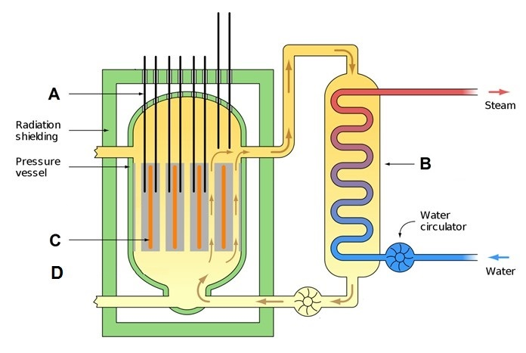

|  |  |
| --- | --- |
| **A: ___________________** | **B: ___________________** |
| **C: ___________________** | **D: ___________________** |

[4 marks]

1. Explain WHY a moderator is required.

|  |
| --- |
|  |
|  |
|  |
|  |

[2 marks]

1. In two to three short points describe how the energy from the nuclear reactor is converted into electricity.

|  |
| --- |
|  |
|  |
|  |
|  |

[2 marks]

1. While referring to nuclear waste management a journalist quoted, “Strotium-90 will not decay for 28 years” and that, “Strotium-90 will not be safe for 28 years”. Given that the half-life of Strotium-90 is 28 years, examine the validity of these two claims made by the journalist.

|  |
| --- |
|  |
|  |
|  |
|  |

[3 marks]

1. The critical mass of Uranium-235 is about 1 kg. Explain why it is that a 5 kg piece of U-235 that is flattened like a sheet is not capable of exploding.

|  |
| --- |
|  |
|  |
|  |
|  |
|  |

[3 marks]

1. Can Nuclear energy considered to be clean source of energy? What are some of the arguments for and against this?

|  |
| --- |
|  |
|  |
|  |
|  |
|  |

[4 mark]

1. Uranium is used as fuel for nuclear reactors. It was also used as fuel in Little Boy, the bomb which was dropped on Hiroshima on 6th August 1945.  
   Compare and contrast how the same U-235 radioisotope is used in these two vastly different applications. Your response should explain how U-235 is capable of undergoing an explosive reaction, but can also be used as fuel in a nuclear reactor without leading to an explosive reaction.  
   Your response is expected to include a comparison of:
   1. Composition of Uranium (enrichment)
   2. Shape of the devices
   3. Mass of Uranium-235
   4. Presence or absence of external factors such as “control rods” and its effects

|  |
| --- |
|  |
|  |
|  |
|  |
|  |
|  |
|  |
|  |
|  |
|  |
|  |
|  |
|  |
|  |
|  |
|  |
|  |
|  |
|  |
|  |

[8 marks]